Free Yoga classes for parents in Radharc Na Mara School. Starting Friday 30th @9am-10am, every Friday. Places are limited, so if interested, please what’s app/text/ring Sarah Curran HSCL coordinator on 087-1953504 by Wednesday 28th. If over-subscribed, names will be chosen at random. I look forward to seeing you then. Come and exercise, relax and meet other parents!
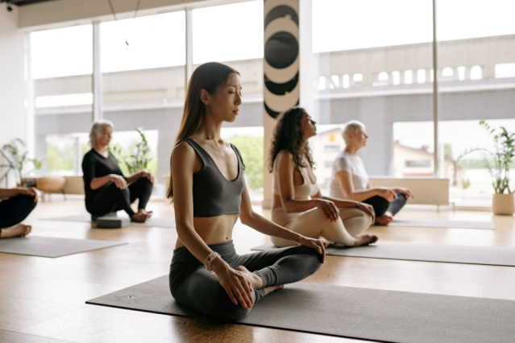
=====================================

Parent walking Group
Parents, have you 30-40 minutes every Monday morning after school drop-off?? I’m starting a walking group Monday 3rd October@ 9am in St. James Park. Please come and join me, improve your fitness, get fresh air and meet other parents.
Any questions, please contact Sarah Curran HSCL on 0871953504

