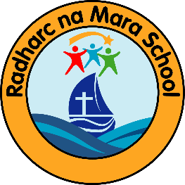Radharc na Mara Primary School
Walter Macken Rd.
Mervue
Galway
H91A3H2
Tel: (091)755920
Roll No: 20554I

1.Child’s Name  ______________________________________  Male _____Female _____ |  | 2. Address  Eircode
3. Date of Birth

 |  | 4.Religion | 5. Place of Baptism (if applicable)
6. Home Phone | 7. Mobile Phone | 8. Email Address (required)
9.Details of Parents or Guardians
Parent/Guardian 1  phone number |  | Parent/Guardian 2  phone number
10. Names of brothers or sisters in or past pupils(of)Radharc na Mara Primary School:

11. Name and address of school or preschool currently attending:

Seeking to enrol at Radharc na Mara Primary School in September 2024 for __________________ Class

PLEASE NOTE: This is neither an offer nor a guarantee of a place in Radharc na Mara Primary School.  I have read the above information and agree that this Application Form does not guarantee my child enrolment at Radharc na Mara Primary School.  Signature________________________________________ |  | Signature of Parent/Guardian  Date______________________

